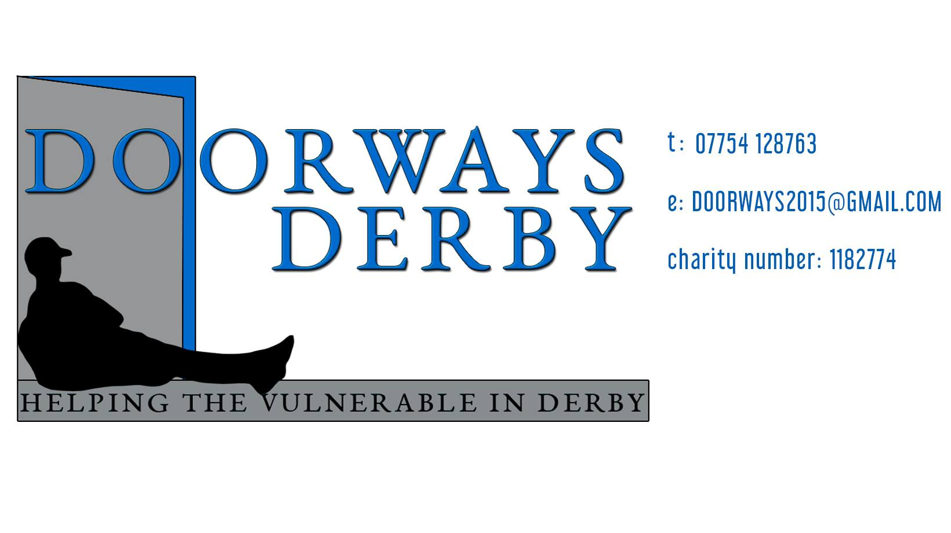

Referral Form
Contact: 07754128763
Website: https://www.doorwaysderby.org/
Email: doorways2015@gmail.com

Full Name
Date of Birth
Current address
Contact Number
Email Address
NHS Number
GP Name address & Contact number

Reasons for referral

If you are referring someone to our service please sign this form to say that you have gained consent from the individual being referred.

Name………………………………………………………………………………………………..

Job Title…………………………………………………………………………………………….

Organisation……………………………………………………………………………………..

Any Specific Support Required

Self Referral

What support do you currently receive at the moment?

How did you hear about Doorways?

Names of any professionals or organisations that you are already receiving help from?

Name of organisation: | Their contact details

By signing below, I give consent to Doorways Derby the authority to receive personal information from my referral agent or from any other agencies involved in my current or previous care/ support, Doorways Derby will handle all information in line with their Confidentiality Policy and Information Governance protocols.

Signature………………………………………… Date……………………………………….

Internal Use only:
Date received
Date Actioned
Outcome : Telephone support, 1-1 support
Assigned to
Signed
Date

Office Address:- 142 Osmaston Park Road, Allenton, Derby, DE24 8EY

